|  |  |  |  |
| --- | --- | --- | --- |
|  | Machine A | Machine B | UNIX |
| IPv4 Address | 193.60.73.204 | 193.60.73.114 | 193.60.76.235 |
| Subnet Mask | 255.255.255.0 | 255.255.255.0 | 255.255.255.0 |
| Default Gateway | 193.60.73.1 | 193.60.73.1 | - |
| Machine's IP Class | Class C | Class C | Class C |
| Machine's Network Address | 193.60.73.0 | 193.60.73.0 | 193.60.76.0 |
| Machine's Host Address | 193.60.73.255 | 193.60.73.255 | 193.60.76.255 |

|  |  |  |
| --- | --- | --- |
|  | Machine A | Machine B |
| Host Name | KW116-032 | KW115-031 |
| Physical Address | 78-24-AF-89-B2-94 | 78-24-AF-89-B3-37 |
| NIC Manufacturer | 78-24-AF | 78-24-AF |
| IPv4 Address | 193.60.73.204 | 193.60.73.114 |
| Subnet Mask | 255.255.255.0 | 255.255.255.0 |
| Lease Obtained | 17 November 2015 09:23:43 | 17 November 2015 12:59:42 |
| Lease Expires | 24 December 2151 19:54:32 | 24 December 2151 19:50:15 |
| Default Gateway Address | 193.60.73.1 | 193.60.73.1 |
| DHCP Server Address | 193.60.48.8 | 193.60.48.8 |
| DNS Servers Addresses | 193.60.73.244 ; 193.60.77.254 | 193.60.73.244 ; 193.60.77.254 |
| Primary WINS Server Address | 193.60.52.230 | 193.60.52.230 |

|  |  |  |  |  |  |  |
| --- | --- | --- | --- | --- | --- | --- |
|  | Machine A | | | Machine B | | |
|  | Network Class | Network Address | Host Address | Network Class | Network Address | Host Address |
| IPv4 Address | C | 193.60.73.0 | 193.60.73.255 | C | 193.60.73.0 | 193.60.73.255 |
| Default Gateway Address | C | 193.60.73.0 | 193.60.73.255 | C | 193.60.73.0 | 193.60.73.255 |
| DHCP Server Address | C | 193.60.48.0 | 193.60.48.255 | C | 193.60.48.0 | 193.60.48.255 |
| DNS Servers Addresses | C | 193.60.73.0;  193.60.77.0; | 193.60.73.255;  193.60.77.255; | C | 193.60.73.0;  193.60.77.0; | 193.60.73.255;  193.60.77.255; |
| Primary WINS Server Address | C | 193.60.52.0 | 193.60.52.255 | C | 193.60.52.0 | 193.60.52.255 |

|  |  |  |
| --- | --- | --- |
| UNIX COMMAND |  | Address(es) |
| **netstat -rn** | Default Gateway Address | 193.60.76.1 |
| **cat /etc/resolv.conf** | DNS Servers Addresses | 193.60.49.84  193.60.48.13  193.60.48.9 |

|  |  |  |  |  |
| --- | --- | --- | --- | --- |
|  | Computer 1 | Computer 2 | Computer 3 | |
| IP Address | 192.168.12.113 | 192.168.12.205 | | 192.168.112.97 |
| Subnet Mask | 255.255.255.0 | 255.255.255.0 | | 255.255.255.0 |
| Default Gateway | 192.168.12.1 | 192.168.12.1 | | 192.168.12.1 |

All three of those computers use the same gateway - 192.168.12.1 - so they access the same network using shared IP address. They also share the same subnet mask - 255.255.255.0 - if permissions are set properly they should be able to communicate to each other except the computer number 3, which is on different subnet 192.168.112.x instead of 192.168.12.x.

|  |  |  |
| --- | --- | --- |
|  | Ping from Windows  Successful? | Ping from UNIX  Successful? |
| ping the IP address of a Windows computer  (IP: ___193.50.73.114___) | Yes | No |
| ping the IP address of a UNIX machine  (IP: ____193.60.76.235___) | Yes | Yes |
| ping the IP address of the default gateway  (IP: ____193.60.73.1__) | Yes | Yes |
| ping the IP addresses of a DNS server  (IP: 193.60.73.244 ; 193.60.77.254  ______________________________________) | Yes | Yes |
| ping the Loopback IP address  (IP: 127.0.0.1) | Yes | Yes |
| ping the hostname of another computer  (hostname: ______KW116-032__________) | Yes | Yes |
| ping www.cisco.com | Yes | Yes |
| ping www.microsoft.com | Yes | Yes |

|  |  |  |
| --- | --- | --- |
|  | Command | Average Delay |
| Windows | Ping –n 5 –l 128 www.cisco.com | 2 ms |
| UNIX | Ping –s [www.cisco.com](http://www.cisco.com) 128 5 | 4.71 ms |

|  |  |
| --- | --- |
| packet size | average time |
| 250 | 3.556 |
| 500 | 3.672 |
| 1000 | 3.851 |
| 2000 | 4.27 |
| 4000 | 4.937 |
| 8000 | 6.145 |
| 16000 | 8.698 |

This shows that every time the packet size is increased, it takes longer to complete. The average number of pings we used were 10. We used [www.cisco.com](http://www.cisco.com) throughout each byte and we took the average from the result we received.

|  |  |  |  |  |  |
| --- | --- | --- | --- | --- | --- |
| Domain Name | IP addresses | Host Name | Network Address | Number of Hops -Windows | Number of Hops - UNIX |
| www.cms.gre.ac.uk | 193.60.72.1; 193.60.77.235 | cms-webserver.cms.gre.ac.uk | 193.60.72.0;  193.60.77.0 | 2 | 2 |
| staffweb.cms.gre.ac.uk | 193.60.72.1;  193.60.76.168 | staffweb.cms.gre.ac.uk | 193.60.72.0;  193.60.76.0; | 2 | 1 |
| www.gre.ac.uk | 193.60.72.1;  193.60.78.101 | gmwebsitevip.gre.ac.uk | 193.60.72.0;  193.60.78.0 | 2 | 2 |

|  |  |  |  |  |  |
| --- | --- | --- | --- | --- | --- |
| Domain Name | IP addresses | Host Name | Network Address | Number of Hops -Windows | Number of Hops - UNIX |
| www.amazon.com | 54.239.17.6;  54.239.26.128 | www.amazon.com | 54.239.17.0;  54.239.26.0 | 30 | 30 |
| www.google.com.au | 173.194.67.94;  173.194.45.63 | www.google.com.au | 173.194.67.0;  173.194.45.0 | 13 | 13 |
| www.gov.hk | 68.232.34.73;  68.232.34.73 | dual46.gs1.wcp.v2cdn.net | 68.232.34.0;  68.232.34.0 | 10 | 10 |

|  |  |  |  |  |
| --- | --- | --- | --- | --- |
| Task | Windows Command | UNIX Command | Windows | UNIX |
| Show all active connections | netstat –a | netstat –a | - | - |
| Show all active TCP connections in numerical form | netstat -p tcp -n | netstat –f inet –n | - | - |
| Show all active TCP connections with Fully Qualified Domain Names for foreign addresses | netstat –p tcp -f | netstat –n | - | - |
| What are the number of IP packets received and sent since boot-up? How many were in error? | netstat –s –p ip | netstat -f inet -P ip -s | Packets Received:  6153511  Packet Sent:  4599557  Errors:  0 | Received: 3454099453  Packet sent: =3189353102  Errors: 0 |
| What are the numbers of IP packets sent and received in a typical 10 second interval? | netstat –s –p ip 10  CTRL + C on second display to stop | netstat -f inet -P ip -s 10  CTRL + C on second display to stop | Packets Received:  6256709  Packet Sent:  4600236  Errors:  0 | Received: 1420  Sent: 1320 |
| What are the numbers of TCP segments transmitted and received in a typical 20 second interval? How many retransmissions were there? | netstat –s –p tcp 20  CTRL + C on second display to stop | netstat -f inet -P tcp -s 20  CTRL + C on second display to stop  tcpInSegs and tcpOutSegs showed segments transmitted and received, tcpRetransSegs showed the number of segments retransmitted. | Received: 3570447  Sent: 2437852  Retransmission: 8776 | Received:  534  Sent:  335  Retransmitted:  0 |
| UDP datagrams - what are the numbers transmitted and received in a typical 20 second interval? | netstat –s –p UDP 20  CTRL + C on second display to stop | netstat -f inet -P udp -s 20  CTRL + C on second display to stop | Received : 913706  Sent: 425203  Errors : 0 | Received:  44  Sent: 54 |
| How many ICMP messages were sent and received in a typical 20 second interval? | netstat –s –p ICMP 20  CTRL + C on second display to stop | netstat -f inet -P icmp -s 20  CTRL + C on second display to stop | Received: 17  Sent: 19  Errors: 0 | Received: 3  Sent: 2  Errors: 0 |
| List the routing table entries | netstat –r | netstat –r | Refer to Figure 1.1 | Refer to Figure 1.2 |

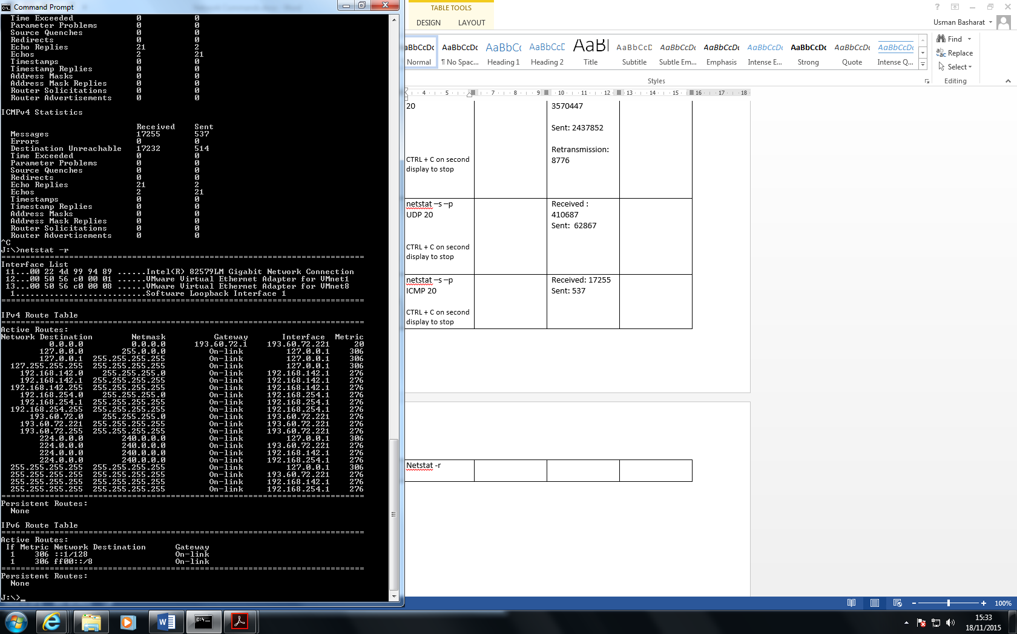**Windows**

Figure 1.1

**UNIX**

Figure 1.2

